TYPES OF NETWORK

## CLASSIFICATION OF AREA BY THEIR GEOGRAPHY

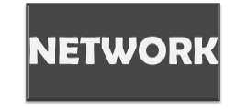

* **LAN is a network which is designed to operate over a small physical area such as an office, factory or a group of buildings.**
* **LAN’s are easy to design and troubleshoot**
* **Exchange of information and sharing of resources becomes**

easy because of LAN.

* **In LAN all machines are connected to a single cable.**
* **Different types of topologies such as star, tree, bus, ring,**

etc Can be used

* **It is usually a privately owned network.**
* **Early LANs had data rates in the 4 to 16 megabites per seconds(mbps) but today however,speeds are normally 100 or 1000 mbps.**
* **Wireless LANs are the newest evolution in LAN technology.**

|  |  |
| --- | --- |
| **ADVANTAGES** | **DISADVANTAGES** |
| **Cost reductions** through **sharing** of **information and databases, resources and**  **network services.** | **Special security measures** are needed **to stop** users from **using programs and data that**  **they should not have access to** |
| Increased **information exchange** between different **departments in**  an **organization**, or between **individuals.** | **Networks** are **difficult to set up** and need to be **maintained** by **skilled technicians**. |
|  | **If the file server develops a serious fault, all the users are affected**, rather than just one  user in the case of a stand-  alone machine. |

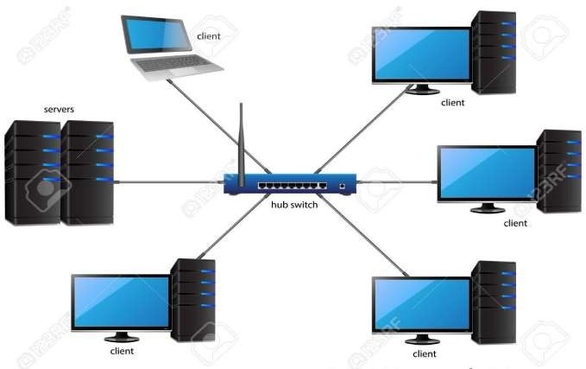

* **WAN is a network that spans over a large distance (geographical location),usually to interconnected multiple LANs**
* **When the computers to be connected to each other are at widely separated locations a local area network cannot be used so then the wide area network(WAN) is installed.**
* **The internet is the largest WAN spanning the earth**
* **A network device called a router connects LANs to a WAN.**
* **Most WANs are not owend by any one organization but rather exists collective or distributed ownership or management.**
* **The communication between different users of WAN is established using leased telephone lines, satellite links and similar channels.**
* **It is cheaper and more efficient to use the phone network for the link.Most WAN networks are used to transfer large blocks of data between its users.**

|  |  |
| --- | --- |
| **ADVANTAGES** | **DISADVANTAGES** |
| **Covers a large geographical area** so **long distance businesses can connect** on the one **network.** | **Need a good firewall to restrict outsiders**  from entering and disrupting the network |
| **Shares software** and **resources with connecting workstations. Messages** can be **sent** very **quickly to anyone** else **on the network.** | Setting up a **network** can be an **expensive, slow and complicated.** The **bigger the network** the **more expensive** it is. |
| **Everyone on** the **network** can **use** the **same data.** This **avoids problems** where some users may have **older information** than others. | Once set up, **maintaining a network** is a **full-time job** which **requires network supervisors** and **technicians** to be employed. |
| **Expensive things (such as printers or phone lines to the internet)** can be **shared by all the computers** on the **network** without having to buy a different peripheral for each computer. | **Security** is a real **issue** when many different **people have the ability to use information from other computers. Protection** against **hackers and viruses** adds **more complexity** and **expense.** |

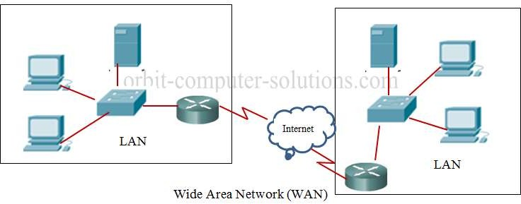

* **MAN network is spanning a physical area larger than LAN**

but smaller than a WANs, such as a city

* **It uses similar technology as LAN.**
* **A MAN typically owned and operated by a single entity such**

as a government body or large corporation

* **It can be a single network such as cable TV network, or a measure of connecting a number of LAN’s or a large network so that resources can be shared LAN to LAN as well as device to device.**
* **A good example of MAN is the part of telephone company network that can provide a high-speed DSL line to the customer.**

|  |  |
| --- | --- |
| **ADVANTAGES** | **DISADVANTAGES** |
| It provides a **good back bone for a large network** and provides greater **access** to **WANs.** | **More cable required** for a MAN connection **from one place to another.** |
| The **dual bus** used in MAN **helps** the **transmission of data in both direction** simultaneously. | It is **difficult to make** the **system secure from hackers and industrial espionage**  **(spying) graphical regions.** |
| A Man usually **encompasses**  several blocks of a city or  an **entire city**. |  |

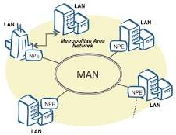

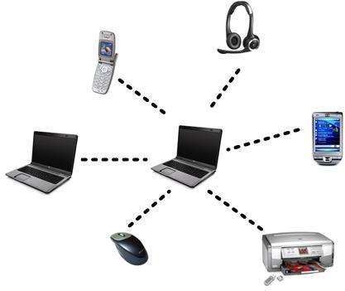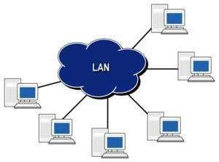

**LAN**

**PAN**

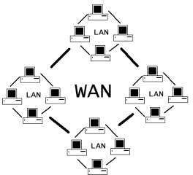

**WAN**

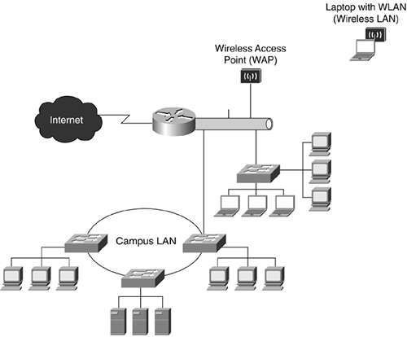

**CAN**

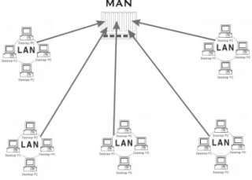

**MAN**

**DISTINGUISH BETWEEN LAN,WAN,MAN**

|  |  |  |  |  |  |
| --- | --- | --- | --- | --- | --- |
|  | **PARAMETERS** | **LAN** | **WAN** | **MAN** |  |
| **Ownership of**  **network** | **Private** | **Private or public** | **Private or public** |  |
| **Geographical**  **area covered** | **Small** | **Very large** | **Moderate** |
| **Design and**  **maintenance** | **Easy** | **Not easy** | **Not easy** |
| **Communication**  **medium** | **Coaxial cable** | **PSTN or satellite**  **links** | **Coaxial cables, PSTN, optical fibre, cables, wireless** |
| **Bandwidth** | **Low** | **High** | **moderate** |
| **Data**  **rates(speed)** | **High** | **Low** | **moderate** |
| **Security** | **High** | **Low** | **moderate** |
| **Cost** | **cheaper** | **expensive** | **costly** |